REPORT

Predicting Air Quality Levels using PM2.5 and weather Data.
Course: ADTA 5340: Discovery and Learning with Big Data
Professor: Dr. Shon Williams
Author: TIRUMALA TEJA YEGINENI
Submission Date: 4/28/2025

1

Table of Contents:
1.Title 4
2.Abstract 4
3. Problem Statement 4
4. Project Architecture Diagram 4
5. Business Understanding 5
6. Dataset Details 5
7. Data Dictionary 5
7.1 Target Variable 6
7.2 Detailed Feature Explanation 6
8. Data Preparation 7
9. Visualizations 7
9.1 Mean PM2.5 value over the months 7
9.2 Distribution of PM2.5 value 7
9.3 Plots of all confusion matrix 8
9.4 Correlation Among Features 8
9.5 Comparison of model accuracies 9
10. Methodologies 9
11. Evaluation Metrics 10
11.1 Random Forest 10
11.2 Logistic Regression 10
11.3 Decision Trees 11
11.4 K Nearest Neighbor 11
11.5 Support Vector Machine 11
11.6 XGBoost 12
11.7 Multi-Layer Perceptron Neural Network (MLP neural network) 12
12. Result 12
13. Best Model Selection 13
13.1 Best Model MLP Neural Network 13
13.2 Second Best Model: Logistic Regression 13
14. Conclusion 13
15. Future Work 13

REFERENCES 14
AI APPENDIX: 15

2
3
- TITLE:
Predicting Air Quality Levels using PM2.5 and Weather Data.

- Abstract:
The goal of this project is to predict the daily levels of air quality in particular area in Los Angeles County, California. Used historical concentrations of PM2.5 pollutant and atmospheric conditions to predict air quality levels. Classified PM2.5 readings into Air Quality Index (AQI) categories and considered this issue as a multi-class classification problem. Evaluated the performance of some machine learning algorithms, including Random Forest, Logistic Regression, XGBoost, Support vector machine, Decision Trees, K- Nearest neighbors and Neural Networks, in order to decide the best model for precise Air Quality levels prediction. Results indicate that Neural Network achieves the highest classification accuracy (97.8%), followed by Logistic Regression (96.61%).

- Problem Statement:
- Objective: Predicting the Air Quality levels based on weather and past PM2.5 values.
- Fine particulate matter (PM2.5) poses a serious health risk, especially in urban areas like Los Angeles where pollution events are frequent.
- Predicting PM2.5 levels can empower policymakers, healthcare providers, and citizens to take preventive actions and mitigate exposure.
- This project aims to develop and evaluate machine learning regression models (such as Random Forest, Linear Regression, Decision Trees, KNN, XGBoost, SVR, and Neural Networks) to predict daily PM2.5 concentrations .

- Project Architecture Diagram:
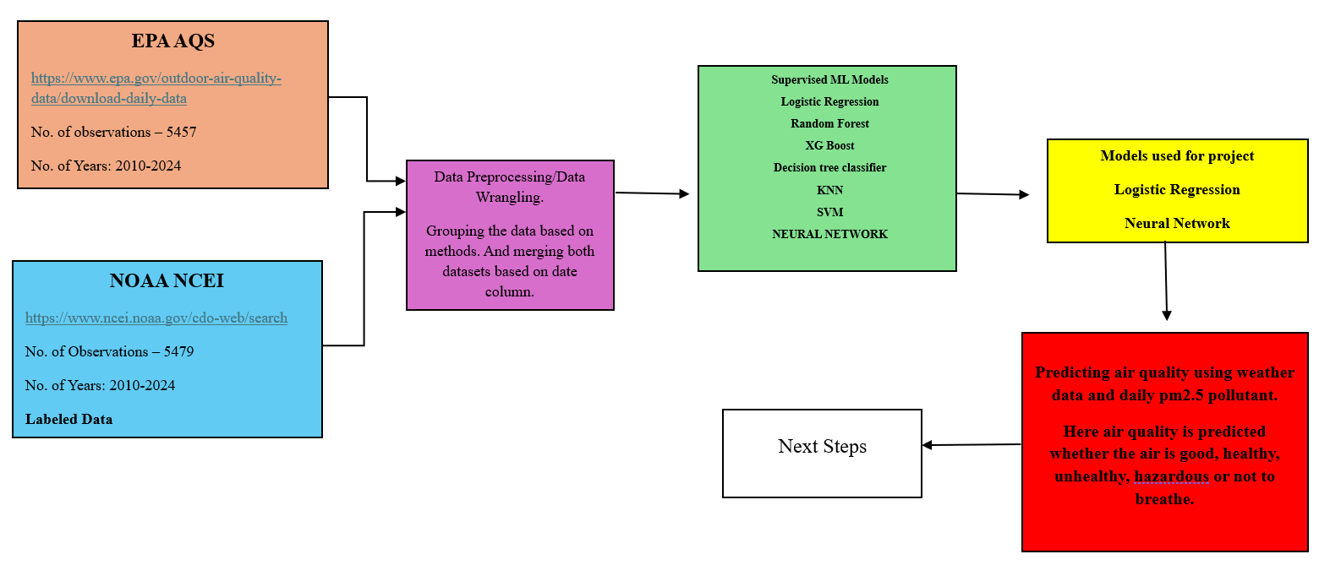
4

- Business Understanding:
PM2.5 stands for the Particulate matter that is 2.5 micrometers or smaller in diameter. This means the particles are 30 times smaller than the hair of the human. These particles are made up of the dust , smoke, liquid droplets etc. If PM2.5 presents in the air it can penetrate deep into the lungs and if there is possibility it can enter into the bloodstream too causing unhealthy conditions like asthma, heart disease and respiratory infections. So it is mainly dependent on the weather conditions. So by taking temperature, precipitation, visibility and pm2.5 daily data as features to predict the air quality. Organizations like the EPA, NOAA, and private firms are also working on similar air quality forecasting solutions.

- Dataset Details:
- I have taken PM2.5 daily values from the Environmental Protection Agency Air Quality System (EPA AQS). And it contains data from 2010 to 2024. And there are 12967 rows and 22 columns in this dataset.
- And the weather data is collected from the National Oceanic and Atmospheric Administration National Centers for Environmental Information (NOAA NCEI). This data is also from 2010 to 2014. And there are 5479 rows and 28 columns.
- I have taken pm2.5 daily data from Los Angeles North Main street. And the weather data from Los angels international airport. Where both the areas are very close within 20miles. So pm2.5 and the weather doesn’t vary much around this region.
Features:
- Weather variables: Temp, RH, Precipitation, Wind Speed, Visibility
- Temporal features: Day of week, Month
- Lag features: PM2.5_lag1, PM2.5_lag2, PM2.5_lag3, PM2.5_roll3
- Engineered interactions: temp_rh, wind_precip, temp_vis

- Data Dictionary:

S. NO | Feature Name | Data Type | Description | Units
1) | PM2.5 | Numeric | Actual dialy pm2.5 concentration | µg/m³
2) | TEMP_C | Numeric | Average daily air temperature | C
3) | PRCP_MM | Numeric | Daily total precipitation | Millimeters(mm)
4) | WDSP_MS | Numeric | Average daily windspeed | Meters per second(m/s)
5) | VISIB | Numeric | Average daily horizontal visibility | Kilometers(km)
6) | RH | Numeric | Average daily relative humidity | Percentage(%)
7) | PM2.5_lag1 | Numeric | PM2.5 value 1 day before | µg/m³
8) | PM2.5_lag2 | Numeric | PM2.5 value 2 days before | µg/m³
9) | PM2.5_lag3 | Numeric | PM2.5 value 3 days before | µg/m³
10) | PM2.5_roll3 | Numeric | 3 day rolling mean | µg/m³
11) | temp_rh | Numeric | Product of temperature and relative humidity | C * %
12) | wind_precip | Numeric | Product of windspeed and precipitation | m/s * mm
13) | temp_vis | Numeric | Product of temperature and visibility | C * km
14) | Day_of_week | Categorical | Day of the week when measurement taken | (0-6)
15) | month | Categorical | Month number when measurement taken | (1-12)
16) | PM2.5_AQI | Categorical | Air Quality index category based on PM2.5 value. | Classes(0,1,2,3)

7.1 Target Variable: PM2.5_AQI Category(0=Good, 1= Moderate, 2=Unhealthy for sensitive groups, 3= Unhealthy, 4= Very Unhealthy/Hazardous)

7.2 Detailed Feature Explanation:

- TEMP_C: Temperature in Celsius. It says about the chemical reactions in the atmosphere. High temperatures are linked with the raising PM2.5 levels which result in worst PM2.5 levels.
- RELATIVE HUMIDITY: It is a derived field. Used the standard formula to calculate this. Dew point and temperature is used to calculate relative humidity.
- PRCP_MM: Precipitation in millimetres. If there is precipitation, it results in lower PM2.5. Because it deposits the particles to the ground.
- WDSP_MS: Wind speed measured in the metres per second. If there are strong winds present they can disperse the pollutants. Weak winds can trap them.
- VISIB: Visibility measured in kilometres. Inversely related to the PM2.5 values. If there is lower visibility means there is no particles in the air.
- PM2.5_lag1 : The value of PM2.5 1 day before. Because PM2.5 doesn’t change drastically overnight. There is some correlation with the previous and next days.

5
- PM2.5_lag2: The value of PM2.5 2 days before. It captures the broader trends if there is any pollution event going on.
- PM2.5_lag3: The value of PM2.5 three days before to capture the longer memory for the model.
- PM2.5_roll3: Three day rolling average. It is used to smoothening the curve.
- Temp_rh: Product of temperature and relative humidity. They captures the common trends. For example high temperature and high relative humidity are result in the smog formation.
- Wind_precip: Product of windspeed and temperature. For example high wind and rain combination may result in removing pollutants.
- Temp_vis: Product of temperature and visibility. It says how the heat is correlated with the visibility.
- Day_of_week: 0-6(Monday-Sunday). Helps in identifying the days which have highest and lowest.
- Month: 1-12. Used to capture trends in each month.

- Data Preparation:
- The data is taken from the 2010 to 2024. I have downloaded the data for each year individually.
- So the data is merged and made into one csv file. The EPA AQS data contains 12967rows. This means on the same date the values are measured by different instruments.
- So I grouped and averaged the data in EPA file using the date column. After that it contains 5457 rows. And selected only date, pm2.5 daily data column. So EPA data now has 5457rows and 2 columns.
- NOAA NCEI data is also from 2010 to 2024. Merged all the files and made into one csv file.
- Merged both the datasets based on date column into one csv file. So final dataset has 5457 rows and 16 columns.
- Converts units of required fields to the standard units.
- New features are created using existing features. And lagged features are created.
- Data cleaning is done after creation of lagged features.
- Labelled column is created based on pm2.5 values.
S. No | AQI Category | PM2.5 Range | Category Label
1) | Good | 0 -12 | 0
2) | Moderate | 12.1 – 35.4 | 1
3) | Unhealthy for sensitive groups | 35.5 -55.4 | 2
4) | Unhealthy | 55.5- 150.4 | 3
5) | Very Unhealthy/ Hazardous | 150.5 + | 4

6

7

- Visualizations:
  - Mean PM2.5 value over the months:
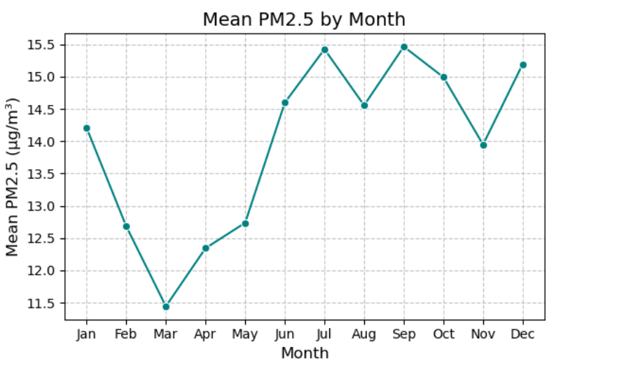

  - Distribution of PM2.5 value:
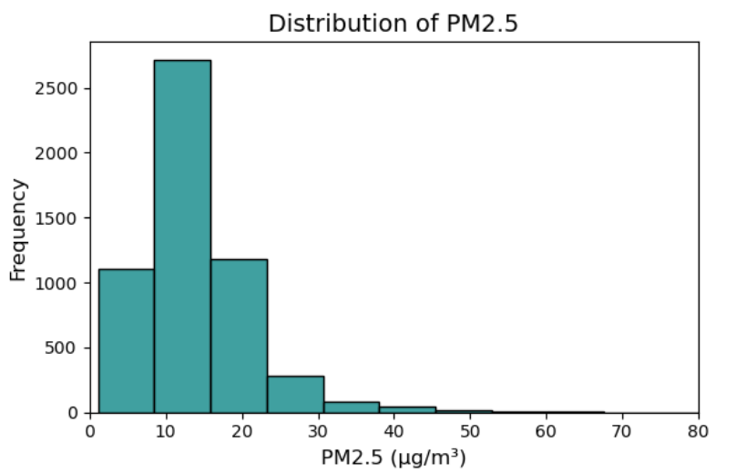

8
  - Plots of all confusion matrix:
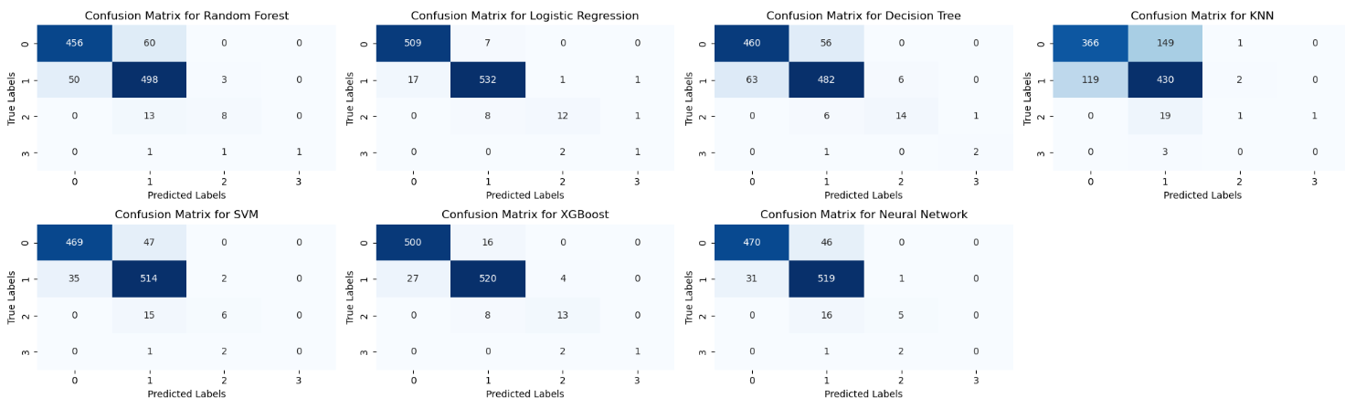

  - Correlation Among Features:
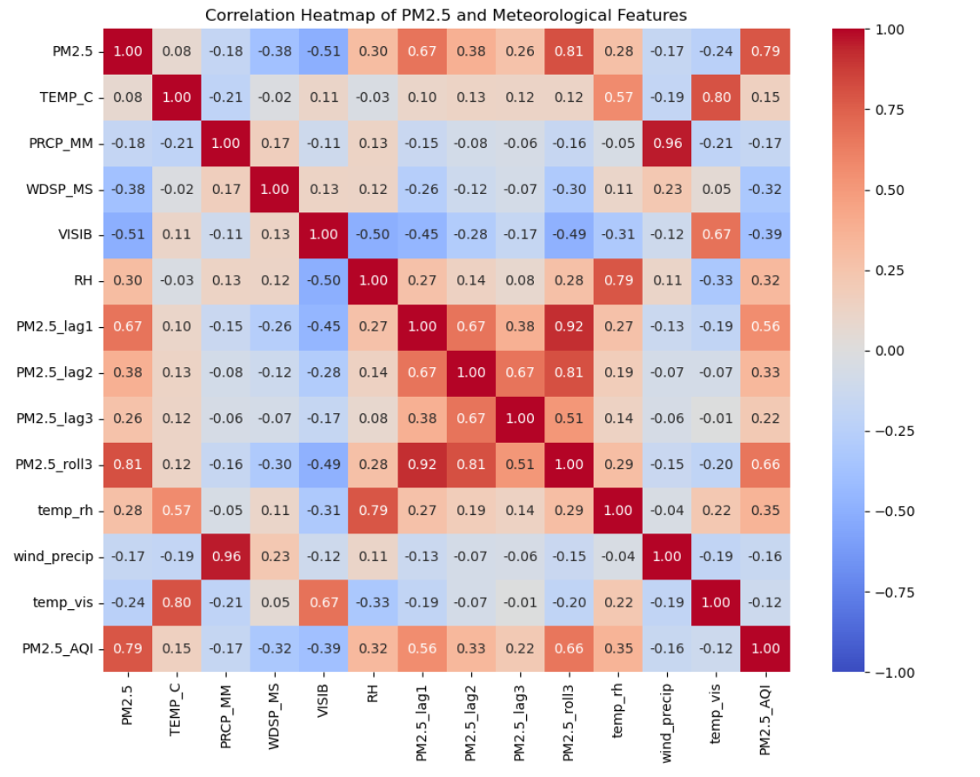

  - Comparision of model accuracies:
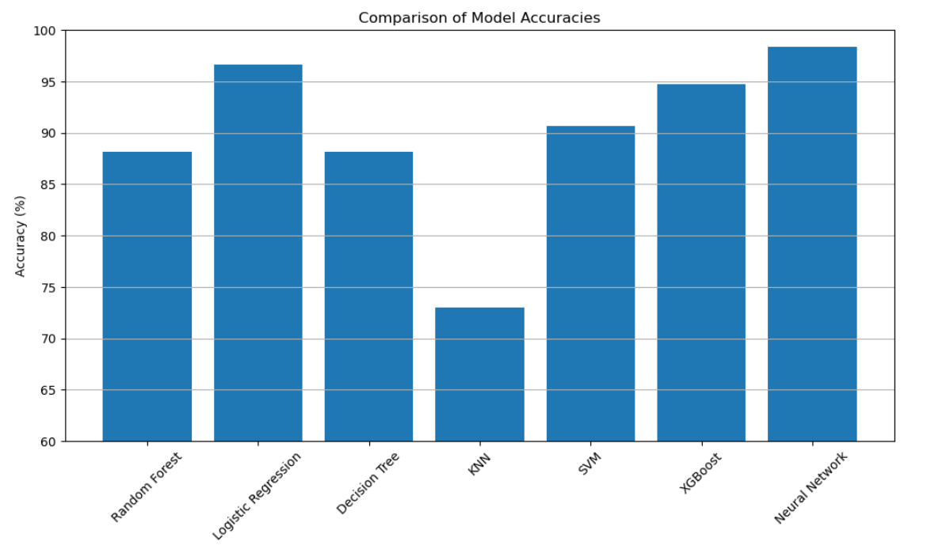

- METHODOLOGIES:
This is a multi-class classification problem. And applied 7 machine learning algorithms that are suitable for the dataset.
S.NO | ALGORITHMS | PURPOSE
1) | Random Forest Classifier | Handles non linearity.
2) | Logistic Regression | Baseline linear model for multi-class
3) | Decision Tree Classifier | Easy interpretability, fast training
4) | K-Nearest Neighbors(KNN) | Simple but sensitive to class imbalance
5) | Support Vector Machines | Good at separating classes, needs scaling of features
6) | XGBoost Classifier | Powerful boosting method for tabular data
7) | MLP Neural Network | Captures complex non-linear patterns

9
- Evaluation Metrics:
  - Random Forest
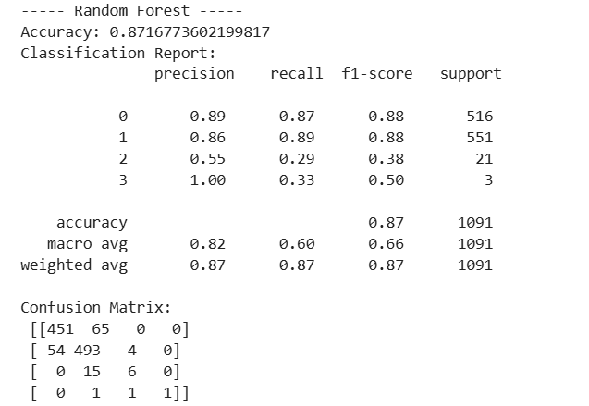

  - Logistic Regression:
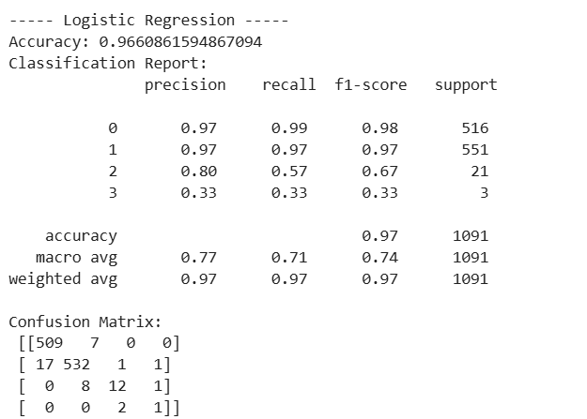

10
  - Decision Tree:
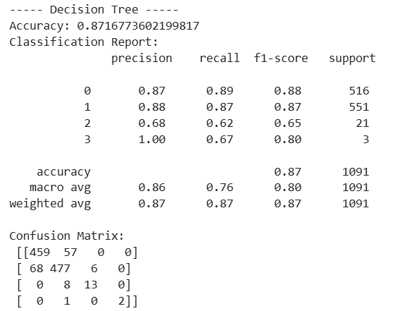

  - K-nearest neighbor
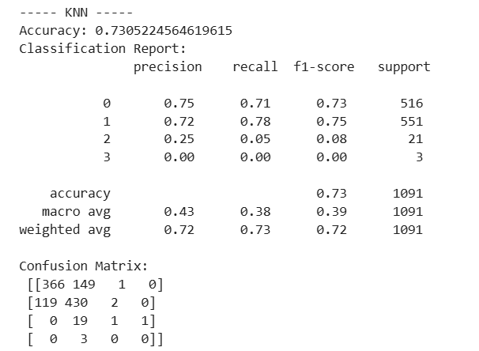

  - Support Vector Machine:
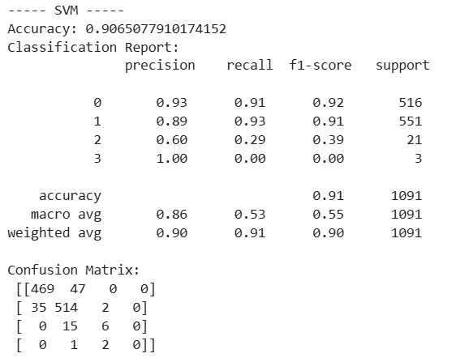
11
  - XGBoost:
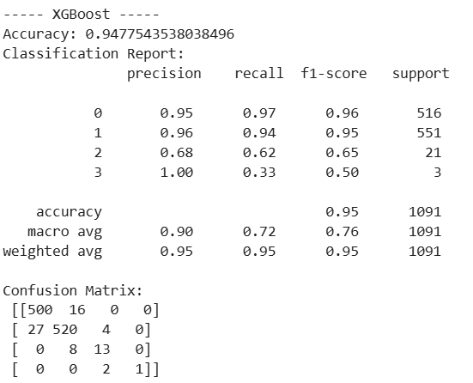

  - Neural Network:
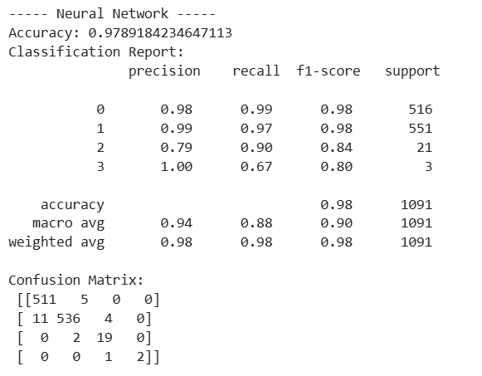

- Results:
Model | Accuracy | F1-Score | Comments
Random Forest | 88.18% | Moderate | Weak on rare classes
Logistic Regression | 96.61% | High | Fast and simple, Slightly rare class missing
Decision Tree | 88.18% | Moderate | Overfitting tendency
K-Nearest Neighbors | 73.05% | Poor | Very weak on rare classes
Support Vector machine | 90.65% | Moderate | Failed to capture rare classes
XGBoost | 94.77% | Good | Slight weakness on rare classes
MLP Neural network | 97.8% | Excellent | Best Overall performances across all classes

12

- Best Model Selection:
  - Best Model: MLP Neural Network:
- Highest accuracy (97.8%).
- Good precision and recall across all categories.
- Dealed well with the non-linear relationships from the lagged and weather features.

  - Second Best Model: Logistic Regression:
- Lightweight, fast and interpretable.
- Still achieves very high accuracy (96.61%).

- Conclusion:

This project has shown that it is feasible to utilize machine learning models, namely MLP Neural Networks and Logistic Regression, to forecast PM2.5 AQI levels for one area in Los Angeles County based on historical weather and pollution data. The addition of lagged PM2.5 terms, meteorological variables, and designed interactions significantly enhanced model performance. This approach may be expanded to include real-time air quality forecasting, early public health alerts, and environmental policymaking.

- Future work:
- Will expand the dataset to include pollutants like O3, NO2, CO for full AQL prediction.
- Will Address the class imbalance by incorporating more data or will use oversampling techniques like SMOTE.
- Will perform hyperparameter tuning for models like XGBoost and MLP for better results and optimization.

13
14

REFERENCES
[1] Chen, T., & Guestrin, C. (2016). XGBoost: A scalable tree boosting system. Proceedings of the 22nd ACM SIGKDD International Conference on Knowledge Discovery and Data Mining, 785–794. https://doi.org/10.1145/2939672.2939785

[2] National Oceanic and Atmospheric Administration. (2024). Global Historical Climatology Network – Daily (GHCN-D). National Centers for Environmental Information. https://www.ncei.noaa.gov/products/land-based-station/global-historical-climatology-network-daily

[3] Rumelhart, D. E., Hinton, G. E., & Williams, R. J. (1986). Learning representations by back-propagating errors. Nature, 323(6088), 533–536. https://doi.org/10.1038/323533a0

[4] U.S. Environmental Protection Agency. (2024). Technical Assistance Document for the Reporting of Daily Air Quality – the Air Quality Index (AQI). https://www.epa.gov/air-quality-index/technical-assistance-document-aqi

[5] World Health Organization. (2021). WHO global air quality guidelines: Particulate matter (PM2.5 and PM10), ozone, nitrogen dioxide, sulfur dioxide and carbon monoxide. World Health Organization. https://www.who.int/publications/i/item/9789240034228

[6] Zhang, Y., Bocquet, M., Mallet, V., Seigneur, C., & Baklanov, A. (2012). Real-time air quality forecasting, Part I: History, techniques, and current status. Atmospheric Environment, 60, 632–655. https://doi.org/10.1016/j.atmosenv.2012.06.031

[7] Pope, C. A., & Dockery, D. W. (2006). Health effects of fine particulate air pollution: Lines that connect. Journal of the Air & Waste Management Association, 56(6), 709–742. https://doi.org/10.1080/10473289.2006.10464485

15
AI APPENDIX
1)
Prompt: what is pm2.5?
Response Summary: PM2.5 refers to particulate matter with less than 2.5 micrometers in size.
It poses notable health hazards due to the fact that it makes its way inside the lungs and blood stream. The common sources are auto exhausts, industrial activities, fire, etc. PM2.5 vs. PM10 differences were noted. Served to convey measurement and environment impact.

2)
Prompt: asking for explanation on measurement and environmental impact
Response Summary: PM2.5 is monitored by air quality stations, hand-held devices, and satellites. Units of measurement are micrograms per cubic meter (µg/m³). Categories for the Air Quality Index (AQI) were instituted. Explained how PM2.5 affects visibility, climate, soil/water pollution, and ecosystems.

3)
Prompt: explain features deeply
Response Summary: Individual explanation of each feature: Meteorological (temperature, relative humidity, visibility, etc.). Lag memory features (PM25_lag1, PM25_lag2, etc.). Engineered interaction features (e.g., temp_rh, wind_precip). Temporal (day of the week, month). Physical relevance was described, along with the reason why they impact PM2.5.

4)
Prompt: Method Description (with PM2.5 sampling instruments list)
Response Summary: Method descriptions are the instruments used for PM2.5 collection. Operationally describe each named instrument (BAM-1020, R&P 2025, SASS, RAAS, etc.). Defined terms such as VSCC, WINS, and SASS and what is being measured (mass or chemical speciation).

5)
Prompt: Is Current Features in the dataset are sufficient to predict air quality levels.
Response Summary: The available data — average temperature, relative humidity, rainfall, visibility, and windspeed — are enough to build a first draft of a PM2.5 forecasting model. Other attributes (e.g., delay and season factors) might make the model more precise.
6)
Prompt: PM2.5 range
Response Summary: Provided PM2.5 AQI ranges based on EPA standards.

7)
Prompt: (SettingWithCopyWarning error message)
Response Summary: To avoid SettingWithCopyWarning, I showed how to safely use functions on pandas DataFrames to categorize PM2.5 using the.loc[:, 'column'] syntax. Provided full code for categorizing levels of PM2.5, as well as an example application.

8)
Prompt: (ModuleNotFoundError: No module named 'xgboost')
Response Summary: Diagnosed ModuleNotFoundError for xgboost and recommended pip install xgboost or conda install.

9)
Prompt: "can we use logistic regression for multi class problems. If yes how?"
Response Summary: Confirmed that logistic regression can handle multiclass problems using multi_class='multinomial' and solver='lbfgs' with example code.

10)
Prompt: "how it shows graphically"
Response Summary: Described and provided examples of how logistic regression partitions feature space into linear decision regions, also called softmax bounds. Provided code using sklearn and matplotlib.
11)
Prompt: "will multiclass logistic curve uses the same as binary logistic regression"
16
17
Response Summary: Explained the significant difference between the sigmoid (binary) and softmax (multiclass) functions. Provide the equations, tables comparing the functions, and softmax output examples.

12)
Prompt: "Predicting daily PM2.5 levels for Los Angeles using historical pollution and weather data."
Response Summary: Given a systematic overview that included data sources (NOAA NCEI, EPA AQS), feature lists, tools (XGBoost, scikit-learn, pandas, Python), and a regression vs classification decision framework.
Critique/Comment: Very helpful. Clearly established the project direction.

13)
Prompt: "I have 0,1,2,3,4 in labeled column. Which ML algorithm can I use?"
Response Summary: The problem is multi-class classification, and some possible models include Random Forest, Logistic Regression, Decision Trees, KNN, SVM, XGBoost, and Neural Networks.
Critique/Comment: Accurate and useful. Helped correctly frame the ML task.

14)
Prompt: "Classification by bucketing PM2.5 into AQI categories."
Response Summary: Confirmed this converts a regression into a classification problem, and offered explanation and category mapping.
Critique/Comment: Very useful clarification. Ensured the project's methodology was correct.

15)
Prompt: "Warnings for Logistic Regression and XGBoost."
Response Summary: Diagnosed convergence warnings and deprecated parameter problems; recommended trying max_iter increase, scaling data, and changing classification report parameters.
Critique/Comment: Very helpful in cleaning and optimizing model code.
16)
Prompt: "Here are model results. Which two models are best and why?"
Response Summary: MLP Neural Network and Logistic Regression were the top models. Provided a complete explanation based on how unusual classes were handled, global correctness, and model stability.
Critique/Comment: Extremely helpful analysis. Strengthened report conclusions.
17)
Prompt: "Any visualization suitable for the models?"
Response Summary: Model accuracies are best displayed using a bar chart, with confusion matrix heatmaps for all models and further F1-score plots.
Critique/Comment: Very valuable. Improved clarity of project results.

18)
Prompt: "Using which formula relative humidity is calculated?"
Response Summary: Explained theoretical formula and practical calculation using Temperature and Dew Point via the August-Roche-Magnus formula.
Critique/Comment: Very clear and technical. Helped in understanding weather feature engineering.

Total Prompts used: 18 major prompts

18

